**Change Request Document**

What is Change Request?

A change request is a formal document that describes the alterations that are proposed for a product or a system by a client or another team member.

Impact analysis has three aspects:

1. Understand the possible implications of making the change. Change often produces a large ripple effect. Stuffing too much functionality into a product can reduce its performance to unacceptable levels.
2. Identify all the files, models, and documents that might have to be modified if the team incorporates the requested change.
3. Identify the tasks required to implement the change, and estimate the effort needed to complete those tasks.

|  |  |
| --- | --- |
| **Change Request** | |
| **Project: SkillUP** | **Date: 01-06-2021** |
| **Change Requestor: Client** | **Change No: 2** |
| **Change Category (Check all that apply):**  □ Schedule □ Cost □ Scope □ Requirements/Deliverables  □ Testing/Quality □ Resources | |
| **Does this Change Affect (Check all that apply):**  □ Corrective Action □ Preventative Action □ Defect Repair □ Updates  □ Other | |
| **Describe the Change Being Requested:**  Client requested to include person’s identity while sharing his/her comments in experience feed page. | |
| **Describe the Reason for the Change:**  Earlier requirement was to display the comments anonymously, but now the requirement is to display the person’s identity as well. | |
| **Describe any Technical Changes Required to Implement this Change:**  Class Design, Database Design, Migrations were updated. | |
| **Describe Risks to be Considered for this Change:**  The Change request will affect the delivery date for the product by 1 day. | |
| **Estimate the Costs Needed to Implement this Change:**  8hr of effort. | |
| **Describe the Implications to Quality:**  Quality of the product won’t be affected by this change. | |
| **Disposition:**  **□** Approve □ Reject □ Defer | |
| **Justification of Approval, Rejection, or Deferral:**  The change was needed as the comments on experience feed were anonymous. All the factors are well evaluated to apply the change. | |

**IMPLEMENTATION OF CHANGE REQUEST**

* Unit Test before adding the change request.

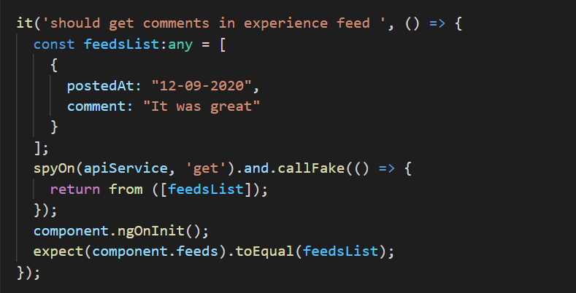

* Unit Test after adding the change request

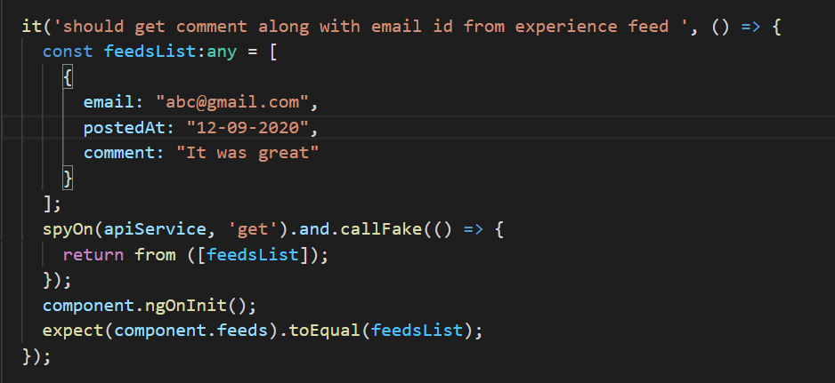

**TEST RESULT**

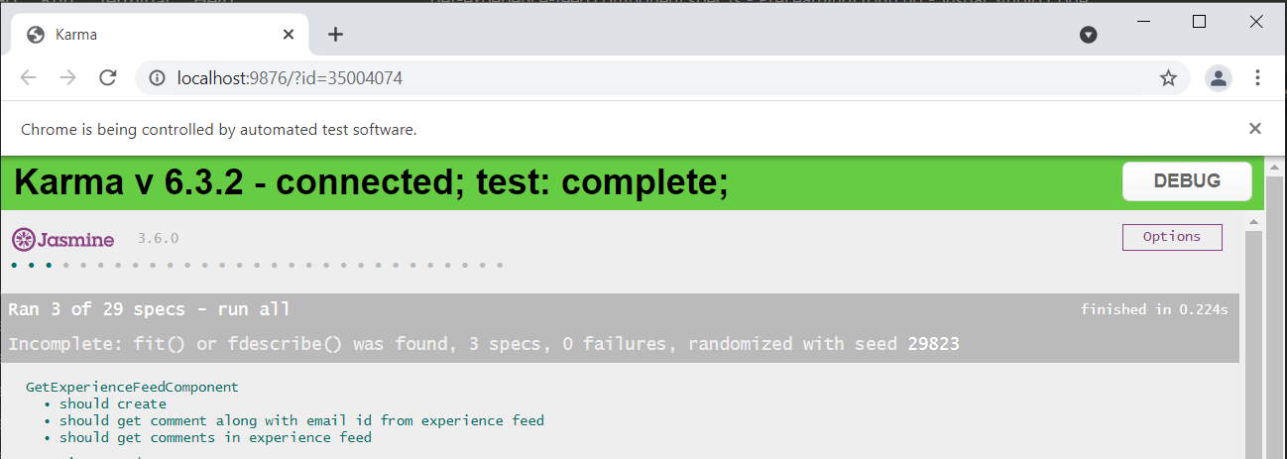

As shown in the picture both the test results are passed, so the change request is not affecting the previous functionalities.